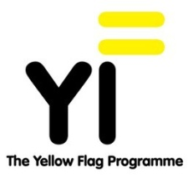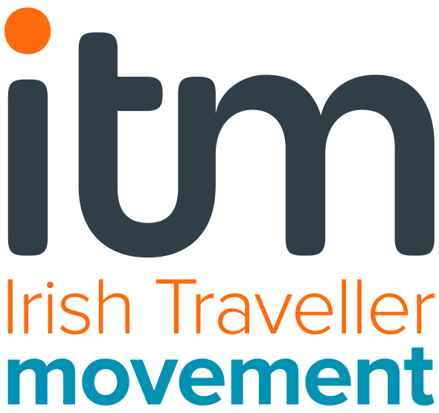

YELLOW FLAG PROGRAMME

To:Denise McGrath (link teacher), Miriam Nolan (Principal), Eilish English
Holy Child National School
Ballycane
Naas
Co. Kildare

Re: Congratulations on Renewing your Yellow Flag! 30 May 2018

Dear Denise, Miriam and Eilis

The Irish Traveller Movement is delighted to formally inform you that Holy Child National School, Naaswill have its Yellow Flag renewed in 2018. Thank you so much for the warm welcome you gave Margaret, Jessica and myselfand the lovely meeting with one of your class groups.

We’d like to commend you on your dedicated work to keep the values of the Yellow Flag vibrant within your school community. It was clear to the assessment team that the Yellow Flag is still alive in the school and that its values inform its everyday life and culture. There is a great presence of intercultural and inclusive work all around the school and the class students we spoke with seemed confident to talk about their Yellow Flag projects, cultural inclusivity and what to do about racism should it occur in their school.

We noted a number of very positive elements to your presentation to us that demonstrated your continuing Yellow Flag work:
- The school continued to hold intercultural events - such as international day, which seems to be a popular, well organised and well-attended event that everyone enjoys and gets involved in. Calling it Intercultural Day can help to include minority ethnicities such as Travellers and second generation migrant students.
- The school still has an active Yellow Flag Committee.
- The school's commitment to celebrating cultural diversity is evident across the school in its art displays, and project work.
- The school takes part in 'Show Racism the Red Card' (which complements the Yellow Flag) and has completed work around anti-bullying
- The school has a diversity code and an anti-bullying policy. The children we spoke to were clear about what they would do if they saw that someone was being bullied - be it racist / identity bullying or otherwise through a very child-friendly an accessible system
- The school provides other opportunities for parents and community members to engage with the school. (The Eid celebration held in school for example)
- The school has a buddy system for newly arrived children from minority ethnic backgrounds.
- The school makes some information available in other languages for children / families –e.g. via intercom.
- The school values children's first and other languages.
The evaluation team usually meets with the Diversity Committee and we would have liked to do that. We realise this was not possible that day but perhaps this could be ensured for your next evaluation. We would also like to see the Yellow Flag folder and the materials you keep to document the ongoing work. We would encourage you to keep making efforts to include information and external inputs on Traveller culture and to continue to build relationships with the Traveller families who attend your school in order to provide the best support to the students. We will follow up with Kildare Action Group during the summer to advise them of your work in the school and explore how they might link with you.

You reported that there were no incidences of racist / identity bullying and that therefore the anti-bullying code had not been used as such. It might be useful at some point for the Diversity Committee to survey the students and/or parents again (as you did for your intercultural review) as a way of exploring that further and also as a way to demonstrate to everyone that the school is committed to being mindful of the potential for such incidences to occur – regrettably racism and discrimination continue to be perpetuated throughout Irish society. We also encourage you to keep up the focus on opportunities within the curriculum to make the link between the larger world through geography, history, CSPE and the positive focus on interculturalism that the school promotes – action projects are an ideal opportunity to do this.

To support our recommendations in this letter, we will be able to make available to you the newest Yellow Flag Resource toolkit when it is finalised in the autumn. There you will find some new resources, including one aimed to support teachers to explore concepts of diversity, inclusion, interculturalism, racism etc. We will let you know as soon as these have been finalised.

Again, we’d like to thank you for a most enjoyable visit and to congratulate you on your work on really embracing the spirit of the Yellow Flag at Holy Child National School. The children are a credit to themselves and to their school community and deserve high praise for their enthusiasm and commitment to such an important part of your school dynamic.

We will deliver your new flag to you in September which will be valid for 3 years. In the meantime, we wish you all a lovely summer.

With kind regards

Elva O’Callaghan
Yellow Flag Co-ordinator
Email: yellowflagprogramme@gmail.comWebsite www.yellowflag.ie
Tel: 01 6796577 or 0872410258

